ECA5701-NANOELECTRONICS
Saambavi U
192512099
CO1
EXPERIMENT 2
Exp. 2. Simulation of Density of States of Quantum Well Structure with Various Nanometer Thickness.

Case Study 1: Simulate the density of states of quantum well of thickness 0.5 nm
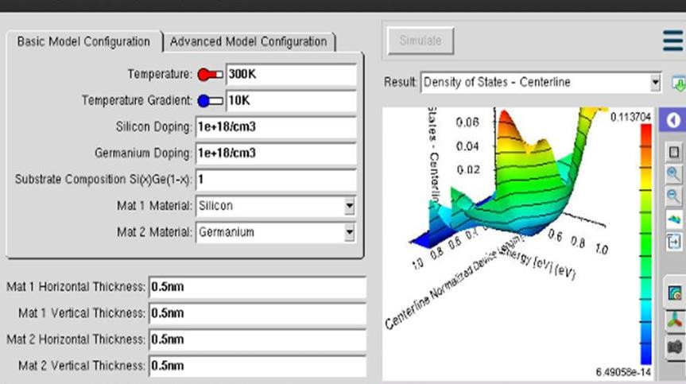
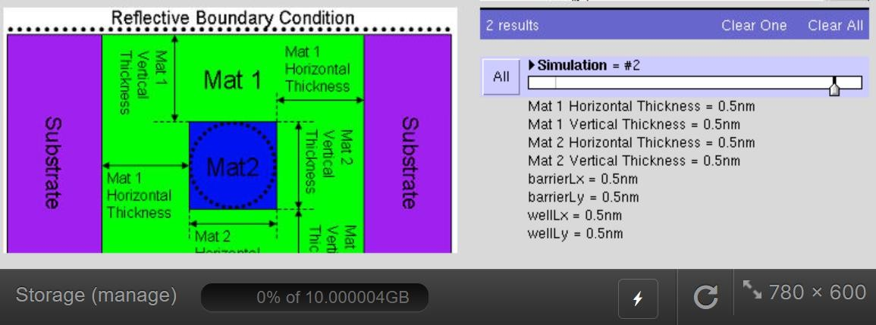

Case Study 2: Simulate the density of states of quantum well of thickness 0.6 nm
